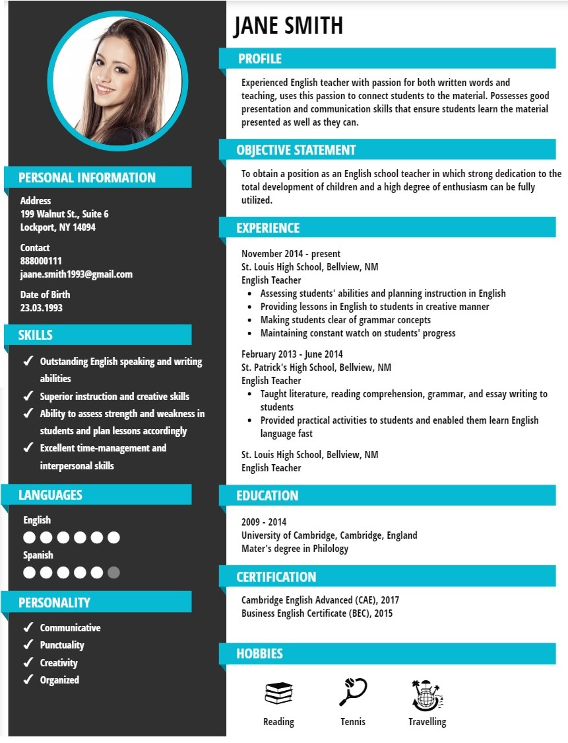

Sample English Teacher Resume

Francis S. Sterrett
205 Waterview Lane
Bellview, NM 88111
Phone: 505-456-9694
Email: fssterett@anymail.com
Career Objective:
To obtain an English teacher position at “Blue Hills High School,” and teach students everything from grammar to writing essay and reading comprehension.
Summary of Skills:
- Outstanding English speaking and writing abilities
- Superior instruction and creative skills
- Experienced in making students comfortable and speak up their problems
- Ability to assess strength and weakness in students and plan lessons accordingly
- High patience to repeat answers for questions asked repeatedly by students
- Excellent time-management, computer, and interpersonal skills
Work Experience:
English Teacher
St. Louis High School, Bellview, NM
October 2014 - Present
- Assessing students' abilities and planning instruction in English
- Providing lessons in English to students in creative manners to help them remembers topics without any problems
- Creating favorable learning environment and motivating students to learn English
- Making students clear of grammar concepts and assisting them in writing essays and stories
- Holding group discussion and debates and ensuring every student contributes his or her thoughts
- Maintaining constant watch on students' progress and evaluating their knowledge through tests
English Teacher
St. Patrick's High School, Bellview, NM
February 2013 - Separation 2014
- Provided practical activities to students and enabled them learn English language fast
- Counseled students low on confidence due to inability to converse in English and prepared them for debate
- Facilitated development of skills and competencies in students by providing them all required resources
- Arranged picnics to zoos and cultural theaters and assisted students in knowing about different species and cultures
- Met and interacted with parents and provided them updates on student progress
- Taught literature, reading comprehension, grammar, and essay writing to students
Education:
- Bachelor's Degree in Education
ABC University, Bellview, NM
2012
Reference:
On request.

